FOR IMMEDIATE RELEASE

Press Contact: Sam Mattingly
SM Communication Solutions
(917) 331-9375
sammattingly@optonline.net

THE 125TH STREET BUSINESS IMPROVEMENT DISTRICT
ANNOUNCES THE PARTICIPATION OF MULTI-HYPHENATE
ENTERTAINER, ENTREPRENEUR AND PHILANTHROPIST, NICK CANNON
AS GRAND MARSHAL FOR THE 28TH ANNUAL HARLEM HOLIDAY LIGHTS EVENT

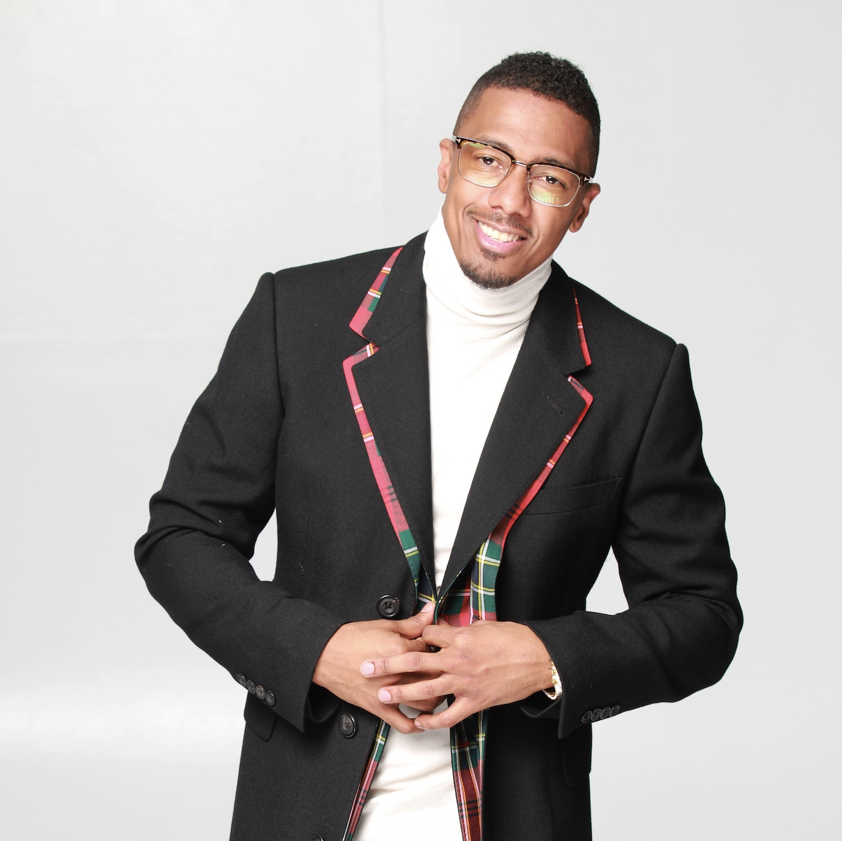

Harlem, New York (September 15, 2021) – The 125th Street Business Improvement District (BID) along with Community Boards 9 & 10, are thrilled to announce that actor, host, comedian, producer, writer, director, DJ, philanthropist, and entrepreneur – Nick Cannon – will serve as the Grand Marshal for the 28th annual Harlem Holiday Lights event to be held on Tuesday, November 16th.

“We are so excited to welcome Nick Cannon to the Harlem community, and we are delighted that he will be joining us this year to kick-off the Holiday Season as the Grand Marshal of the annual Holiday Lights celebration,” said Barbara Askins, President of the 125th St. BID.

In the past the Harlem Holiday Lights has welcomed Harlem resident, American fashion designer and haberdasher, Dapper Dan; actress and playwright Laiona Michelle (Little Girl Blue: The Nina
Simone Musical, Mandela the Musical); and Harlem’s own – author, radio and television personality, and pop-culture aficionado, Bevy Smith – all of whom served as Grand Marshal of the event.

Ms. Askins met with Mr. Cannon over the summer, during his search for a space on the landmark 125th St. corridor to accommodate his artist development project. The two discussed the possibility of his participation in the holiday event, which has become a much anticipated tradition in the community, and he decided it was a perfect opportunity to be a part of something special. Mr. Cannon has already cemented his relationship with the historic Harlem community, which has become home to his daytime talk show, “Nick Cannon”, premiering on Monday, September 27th, and shot at the studios located at 106th & Park Avenue that once served as location for several BET productions.

Nick Cannon has been a premiere name in entertainment for over 20 years, having emerged as a savvy entrepreneur, impactful philanthropist, and dedicated activist over the years. In 2020 Variety recognized Nick’s work and influence with a cover story that further acknowledged his multi-faceted impact on the industry, while reinforcing his desire to include Harlem in his future. That dream has now become a reality.

“Harlem has always had a special place in my heart – it’s been a source of my inspiration, and more importantly a historic, iconic birthplace of culture, expression, creativity and prosperity for the Black community whose influence spans globally today,” says Nick Cannon. “I’m grateful to Barbara and the BID for the opportunity to represent at the Harlem Holiday Lights event – and to play a role in the broader mission of uplifting and inspiring Harlem’s community with this and the other amazing projects that I’m blessed to be working on here. We’re only scratching the surface of what’s to come.”

SAFELY LEVELING UP

While the city continues to slowly reopen after more than a year of lockdown due to the global pandemic, the emphasis will squarely be on the safety of participants, especially as concerns over COVID-19 and the new DELTA variant continue to be a part of daily life. To enable the enjoyment of this year’s event safely, and to level up as a kick-off to the Holiday Season celebrations, the 125th St. BID is launching a comprehensive, immersive digital marketing campaign that reflects Harlem’s Cultural Diversity and contributions to the greater national story.

Using a mix of real and digital experiences including “Community Storytelling”, placemaking, Audio Tours that capture the images and voices of the community; immersive Augmented Reality that creates fun and safe interactive experiences for visitors and residents, the BID hopes to expose a broad audience to the community’s history and important assets (its cultural institutions, landmark sites, and local businesses).

THE CARAVAN’S ROUTE

The Caravan of festive floats departs from 125th Street and Broadway at 6:00 pm ET on November 16th, and continues down the corridor to Adam Clayton Powell Jr. Blvd, turning on to Central Park North/110th Street, where it will turn again on to Malcolm X Blvd and 125th, winding around Marcus Garvey Park and circling around to 126th and 5th Avenue, where it will turn back up on to 125th for the final leg, concluding at Morningside Avenue.

In partnership with the Mt. Morris Park Community Improvement Association, business owners and community residents along the route will add to the festive atmosphere of the evening, by decorating their properties in appropriate holiday decor. The Caravan’s festive floats will fill the route with music and holiday cheer that is infectious.

Mr. Cannon’s participation this year will make the event an especially momentous and memorable occasion.

LEARN MORE

We encourage you to visit the 125th Street BID for additional information and for a schedule of activities.

Broadcast crews, reporters and photojournalists seeking additional information about this event may email or call Sam Mattingly at, sammattingly@optonline.net/(917)331-9375 or contact the 125th Street Business Improvement District at bid125thst@aol.com.

# # #

About the 125th Street Business Improvement District
The 125th Street Business Improvement District, created in 1993, is managed by the 125th Street District Management Association. Property and business owners, community and government leaders, residents and staff, all work closely together to improve the experiences of those who live, work, visit and invest in the Harlem Community. The 125th Street BID seeks to catalyze economic development; encourage the ongoing revitalization and promotion of 125th street as a premier art, culture, and entertainment destination; facilitate active tourism; increase pedestrian mobility and give the streetscape a cohesive modern appearance while reducing clutter; develop additional public space; include public art throughout the district and create a high-quality urban environment that contributes to the identity of the Harlem community.

